**AiDE® Agents Setup Documentation and Understanding**

Documented by Gaganam Krishna

8th April 2025

**As Humans:**

“Human brains trained or acquire knowledge through various means such as schools, colleges, conversations, reading articles, watching movies, TV, news, traveling, and practical experiences in scientific activities. Our nervous system gathers this information and data, allowing us to respond quickly to incidents based on our experiences. “

**What is LLM (Large Language Model):**

1. Think of LLMs like brains that understand and generative Human like language
2. Examples: GPT-4, Claude, Gemini
3. Trained on massive text data
4. Can Answer questions, generate content, write code etc.
5. Example: "Tell me a joke," and it'll provide a funny joke based on the extensive text it has learned from earlier.

**What is Generative AI:**

“Generative AI is a type of Artificial Intelligence that creates the new content, such as text, Images, or music by Leaning patterns from existing data, it often uses LLM to generate human like response and creative outputs.”

**What is an AGENTIC-AI:**

1. Imagine this weekend, I'm planning a short vacation with my family to Goa.

“Plan a weekend trip to Goa. Book evening flights from Hyderabad and reserve a 3-star or 5-star hotel near the beach at an affordable price, considering recent price drops and good ratings.

After two days, arrange a highly rated cab from the hotel to the airport and book return tickets to Hyderabad in Economy class for a night flight.

Retrieve family member details from the file "My_Family_details.txt" on my system”

**Agentic AI = LLM + Memory + reasoning + tools + autonomy**

**What is MCP (Model Context Protocol) server:**

The Model Context Protocol (MCP) is a standardized communication framework that enables AI models to interact seamlessly with external tools, data sources, and APIs.

MCP servers are lightweight applications within this framework that expose specific capabilities, such as APIs, databases, or files, to AI models. This allows AI models to fetch real-time data, execute tasks, and enhance their reasoning capabilities by accessing external resource

M = Model

C = Context (chat history, files, tools)

P = Protocol (rules for how to use context and interact)

Enables LLM to read memory, use tools, and follow structured steps (like API or IDE plugins)

For more info about MCP servers: [GitHub - modelcontextprotocol/servers: Model Context Protocol Servers](https://github.com/modelcontextprotocol/servers)

2. Agentic AI can now perform multiple tasks autonomously by connecting with file & external tools Once connected to the MCP server with the appropriate permissions, it can:

1. Access the file system to read family data.
2. Connect to a flight booking application to check and book flights based on price and timing.
3. Connect to a hotel booking platform to reserve a room for the given dates, comparing ratings and prices from the last three months.

After completing these tasks, it will give us the ticket details.

**What it does:**

Agentic AI autonomously thinks, compares prices, finds the best hotel, reasons its booking decisions, and checks the calendar. It doesn't just answer questions but acts intelligently over time.

**Memento:**

We can customize Agentic AI operations by feeding common required tasks through "Memento." Based on frequently needed operations, you can write the rules in the Memento file.

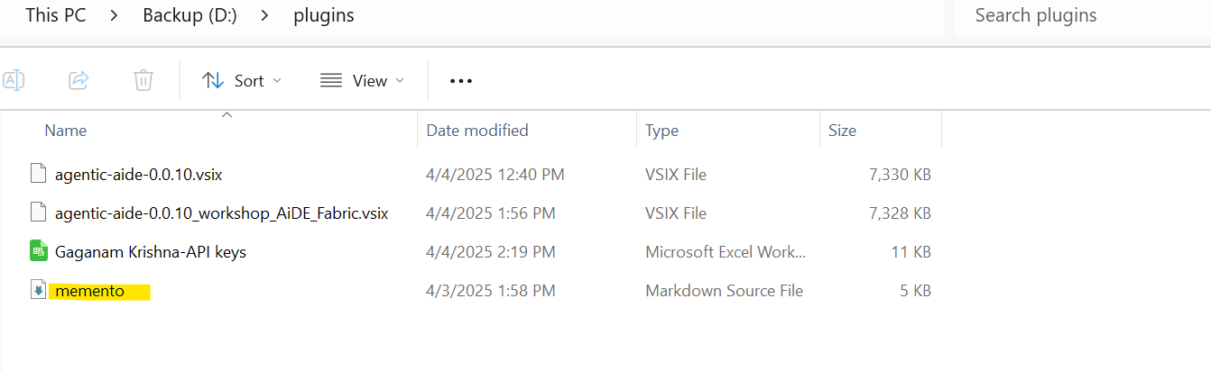**Rules:** We can provide customized rules based on our requirements

**Set up documentation:**

1. Download the VS Code Aide Agents' plugins below and save them in a folder for future reference.

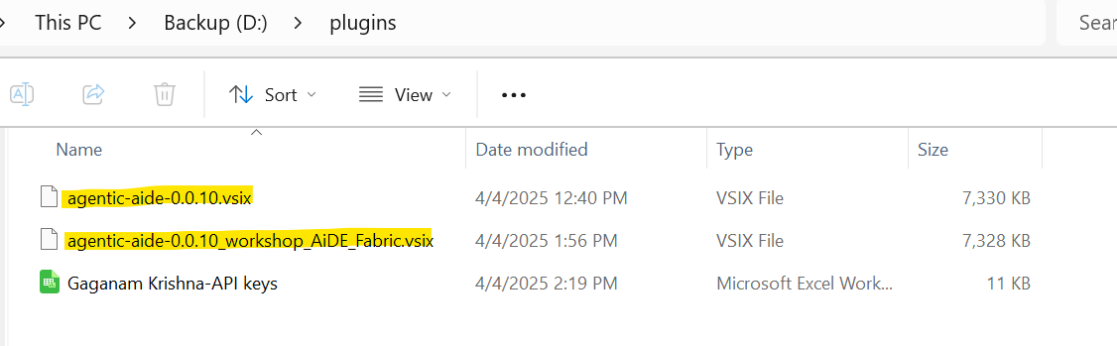

1. Open the VS Code IDE, go to the Plugins section, and click on "Install from VSIX."

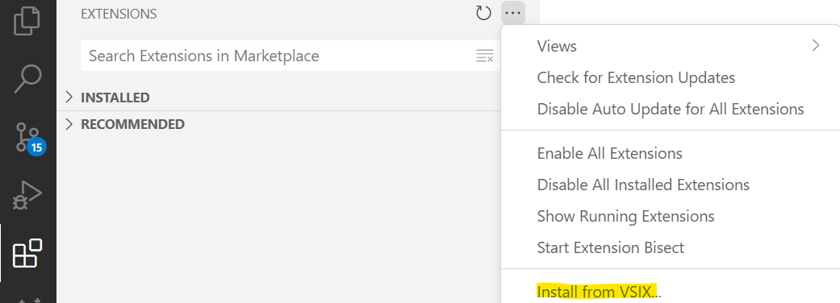

1. Navigate to the specific folder where the plugins are located.

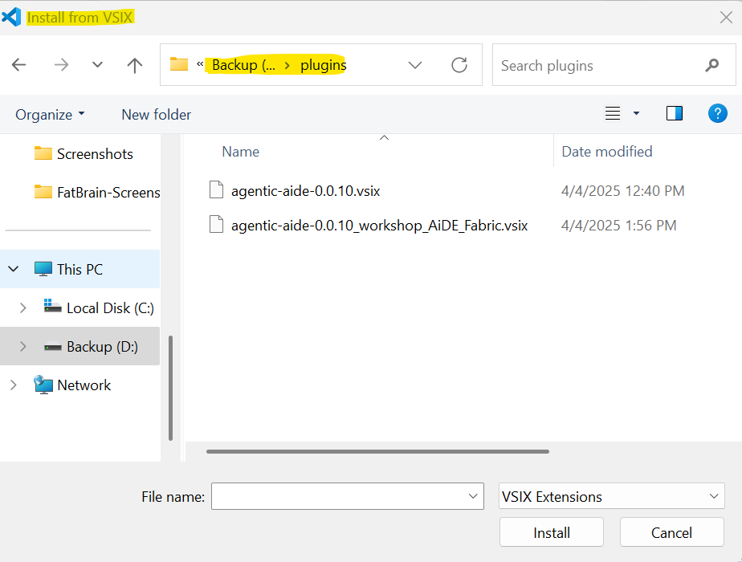

4. Just double-click to install the plugin, then restart VS Code. We are now ready with the plugin 😊.

I hope you have already opened the project you are working on. If not, open your project in VS Code. Currently, I am working on the EMR system as a POC. You should now be able to see the project here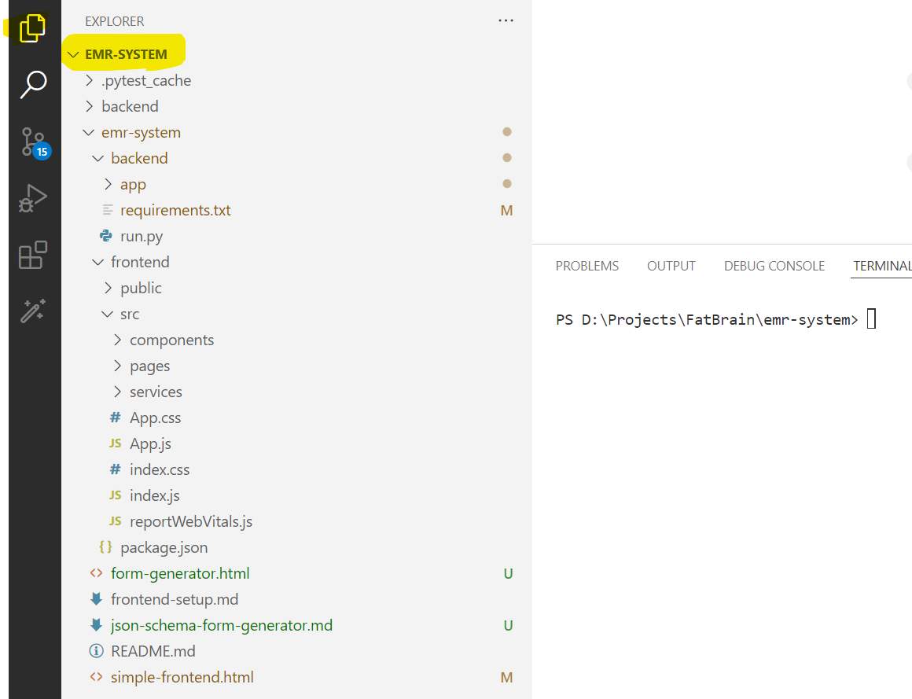

If you are new to the VS Code IDE, spend some time here to familiarize yourself with the environment.

1. Now, let's get back to our plugin setup. Open the magic wand icon in VS Code and click on the settings icon

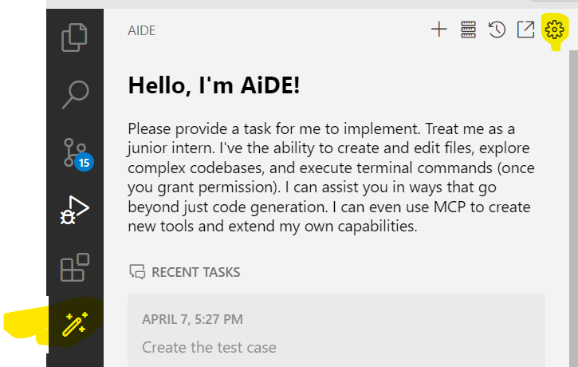

1. Here, you can see the following
   1. API Provider: This will be auto populated based on the plugin you have installed
   2. Base URL: This will be provided to you.
   3. API key: This will be provided to you.

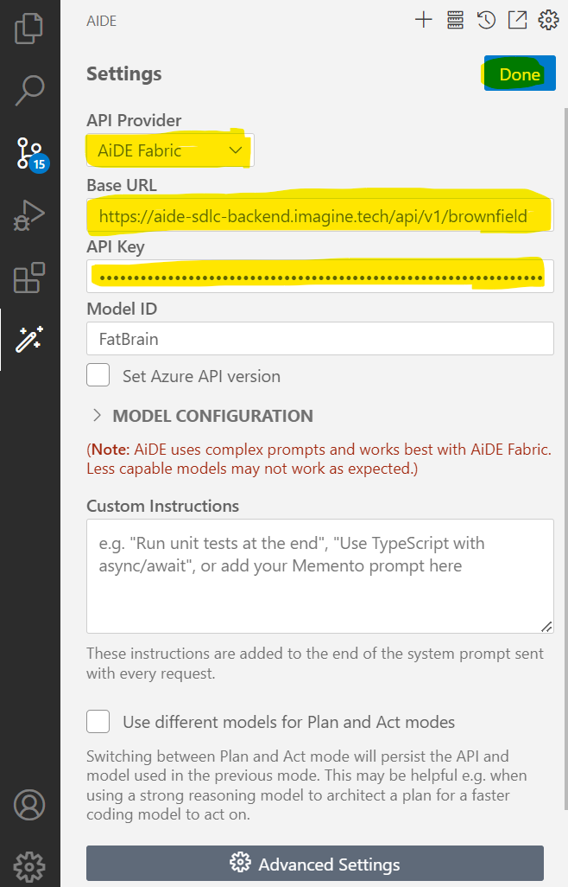

After completing everything, click on DONE. In some cases, clicking DONE won't save the changes. For now, just click on DONE and return to the main screen

1. If auto-save is not working, click on the screen below.

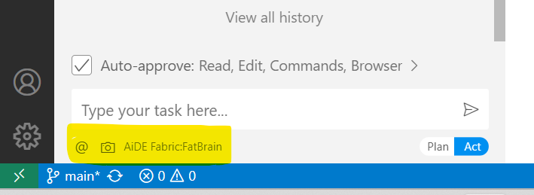

1. If you click here, a pop-up will appear. Enter all the details as discussed above and click outside the pop-up to save automatically

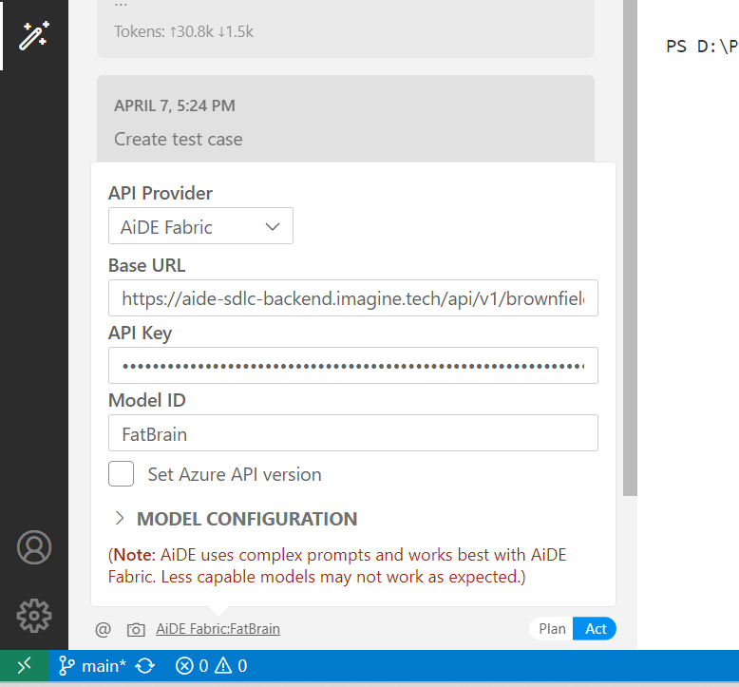

1. Click on the "Auto Approve" checkbox at the button.

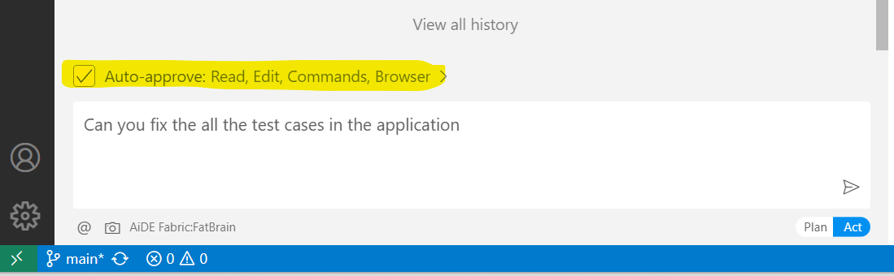

Give approval, and you will see a pop-up. Select the options provided in the pop-up.

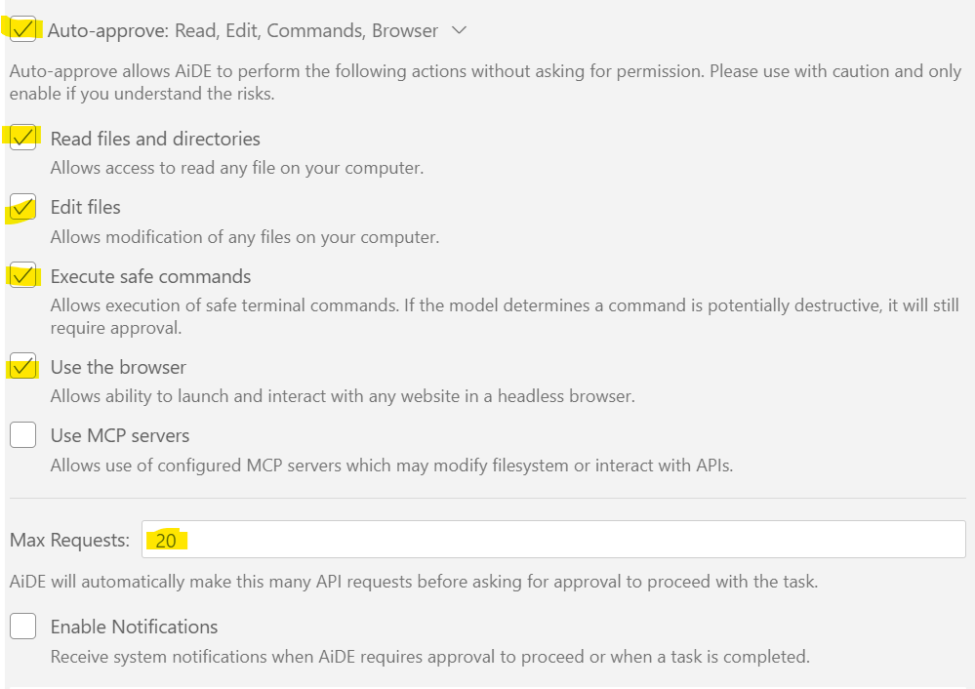  
  
The "Max Request" is the rate limit for API calls. For now, you can set it to 20.

1. I am providing a prompt. Now, it will generate the unit test cases, modify files, compile, build, and run everything.

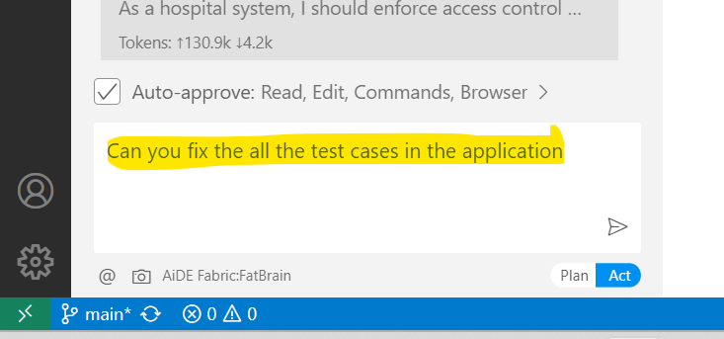

1. It will perform its tasks by manipulating files and taking the necessary actions. Here, we can see the following:  
   Token: Amount of data uploaded and downloaded.

Cache: Generated by processing the given prompt.

Context Window: Entire prompt memory.

API Cost: Amount of money consumed by our prompt.

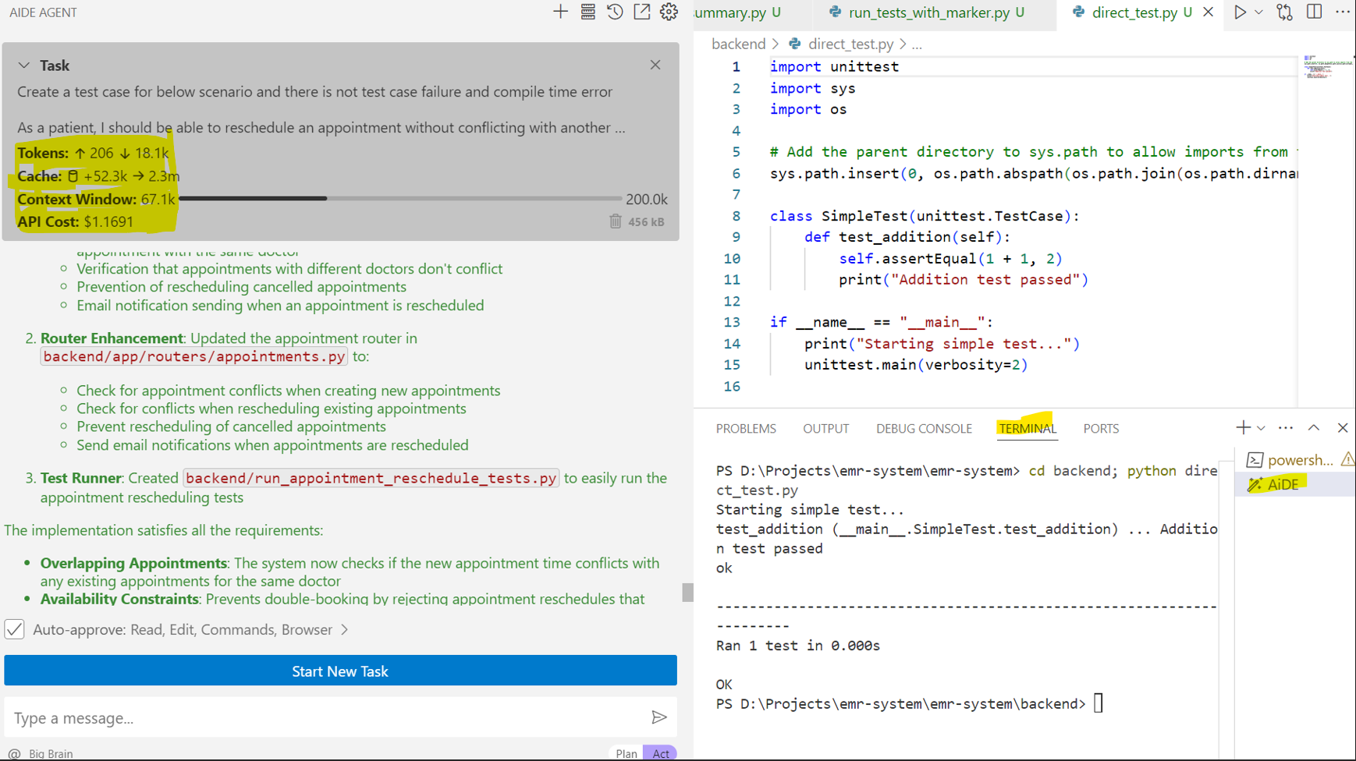

1. It will ask for human interactions in between.

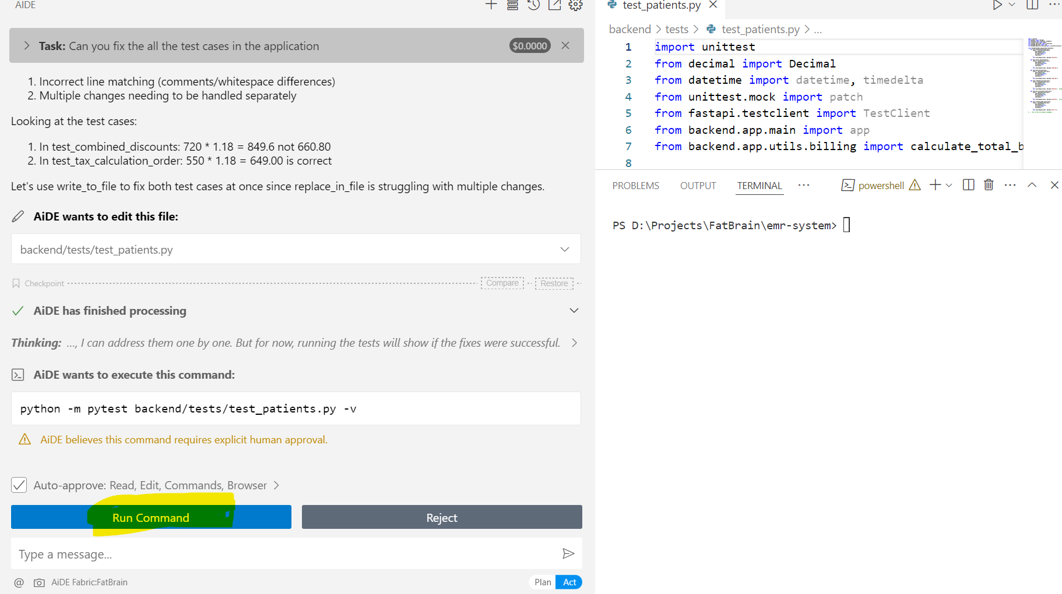

1. All these files are manipulated by aide agent.

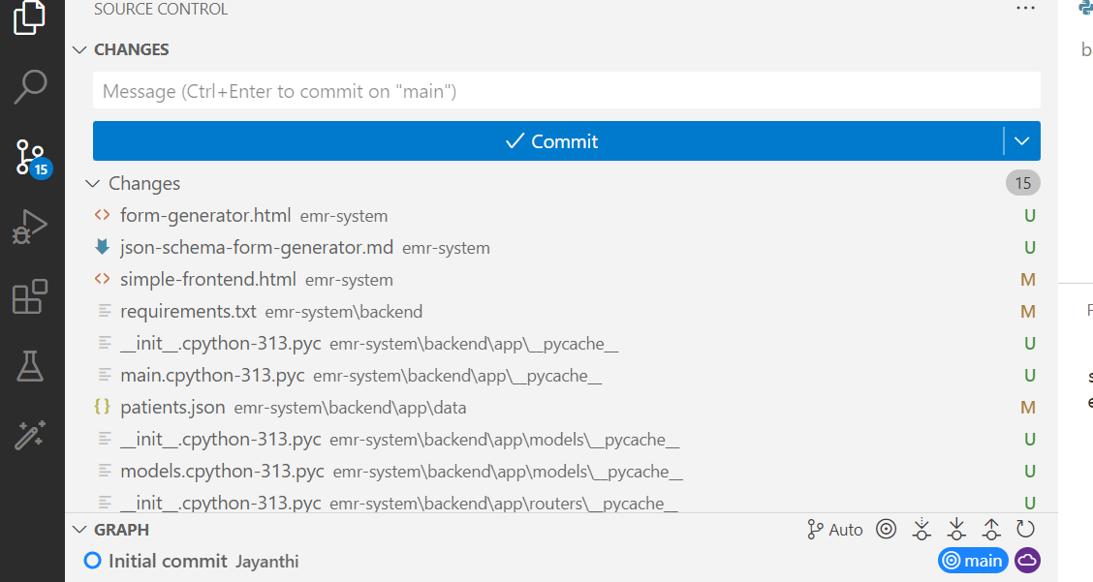

**Note:** As it is AI, it may sometimes produce inaccurate results. Therefore, we need to provide precise prompts based on our requirements to ensure it works correctly 😊 😊

====== Happy AiDEing! ======